Group member work journal Samples

Group members maintained a work journal to track work times, the primary goal of these journals was to identify and shortcoming pertaining to time management and to ensure an organized approach to the design and implementation of the project.

Sample of work diary from Thomas Nixon

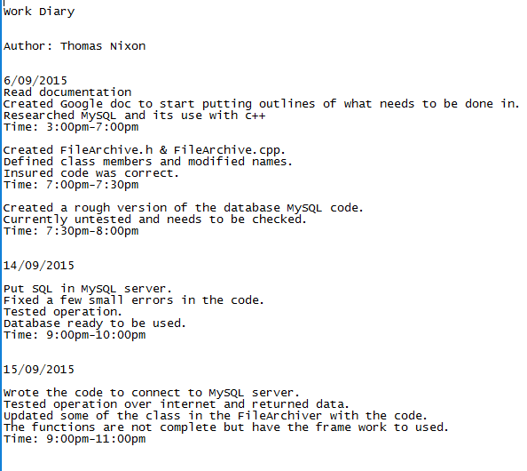

Sample of work diary from Ivana Ozakovic

